IMPORTANT: Please read the instructions below thoroughly before completing the attached Texas Department of Insurance 2014 Texas Policy Count Exhibit - Adobe Acrobat interactive form.
- You have received an email requesting that you complete the 2014 Policy Count Exhibit form (“2014 PCE FORM_distributed.pdf”). You can use Adobe Acrobat or Adobe Reader to fill in this form.

Please see example below:

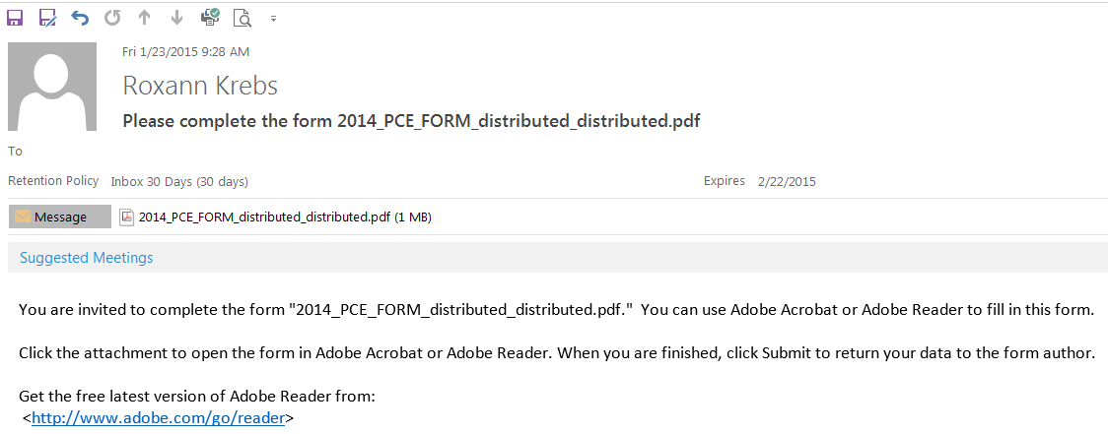
Jack Evins

- You may submit your filing to TDI in any one of the following ways:
Email: Click on the Submit button.
Or, if you are unable to submit the form by email, print the completed form and
Mail it to: Jack Evins
Consumer Protection MC 111-1A
Texas Department of Insurance
P. O. Box 149104
Austin TX 78714-9104
- Important: If you file by email, please do not also mail a paper copy of the filing.
- Questions? Contact Jack Evins by email Jack.Evins@tdi.texas.gov or by phone at 512-676-6215.

- If you already have Acrobat or Adobe Reader, click on the attachment to open the form in Acrobat or Adobe Reader.
- If you do not have Adobe Reader, you can click on the following link to download the latest free version of Adobe Reader: http://www.adobe.com/go/reader
- Once you have opened the form you can begin to fill in the required fields. Required fields are outlined in red on the form.
- The following fields are required fields:
- TDI License # – Enter numerical values only. If you do not know your company’s TDI License number, please look it up on TDI’s website at https://apps.tdi.state.tx.us/pcci/pcci_search.jsp.
- Company Name
- Lines of coverage – Enter numerical values for coverages in force in each blank for each line of coverage (see “Definitions” below). Do not include commas for values greater than 999. Enter a zero if the company had no policies, contracts, or certificates in force covering Texas risks as of December 31, 2014. Note: If your company had no coverages of any type in force in Texas as of December 31, 2014, you may check the “No coverages in force in Texas as of December 31, 2014” box rather than entering a zero (0) value for each line.
- Special instructions for TITLE insurers: Enter the total number of policies written during the preceding five calendar years (2010-2014). This figure is required instead of a count of policies in force as of December 31, 2014.
- Date
- First Name
- Last Name
- Title
- Area Code – Enter numerical values only
- Phone Number – Enter numerical values as follows: 9999999
- E-Mail Address
- TDI may release my e-mail address in response to a public information request? Choose “Do Not Agree” or “Agree.”

DEFINITIONS
Lines of Coverage
- Life – all forms of coverage on the life of a person (whole, universal, term, credit, etc.).
- Annuities – fixed and variable annuities.
- Medicare Supplement/Select – all contracts providing health benefits or services to fill the gaps in the protection provided by the Medicare program.
- All other Health and Accident – all contracts providing or arranging for health care services or covering or indemnifying health care expenses (indemnity/insurance), including disability, credit health/accident/disability, HMO and other managed-care contracts, and long-term care contracts, other than Medicare Supplement or Medicare Select.
- Personal Motor Vehicle – all personal automobile policies covering any type of vehicle, including policies written by assignment through the Texas Automobile Insurance Plan Association (TAIPA).
- Commercial Motor Vehicle – all motor vehicle coverages other than those issued under personal automobile policies, including policies written by assignment through the Texas Automobile Insurance Plan Association (TAIPA).
- Dwelling – all forms of homeowners, renters (tenant), and dwelling fire coverage.
- Workers’ Compensation – policies issued to employers and that indemnify employees for health care expenses or their loss of income, resulting from injuries sustained within the course and scope of their employment.
- Other Property, Casualty, Surety, or Title – all captioned lines, including credit property and credit involuntary unemployment, and farm owners and ranch owners. Exclude motor vehicle, dwelling, and workers’ compensation, as described above.
Policies, Contracts and Certificates
- Individual Policies/Contracts – all policies and contracts not issued to or through a group.
- Group Contracts (master contracts) – all group policies or contracts issued to groups having members (or certificate-holders) located in Texas.
- Group Certificates – the number of Texas members (or, for HMOs, subscribers) covered under any group contract.

- Once you have completed filling in the form, you have the option to print the form you have completed, by clicking on the “Print” button located at the bottom of the form. If you have made a mistake and want to begin again, you may click on the “Clear Form” button, and this button will completely clear the form.

- When you are ready to submit your form, please click on the “Submit Form” button located in the top right corner of the Adobe Form Tool Bar.
Example:
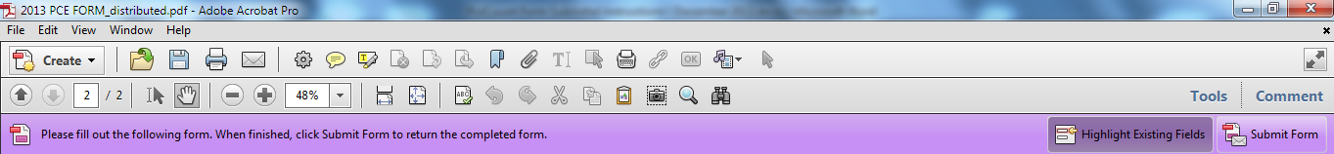

- Once you have clicked on the “Submit Form” button, you will receive a “Send Form” pop-up.

- Enter your Email Address, your Full Name, and click “Send.”

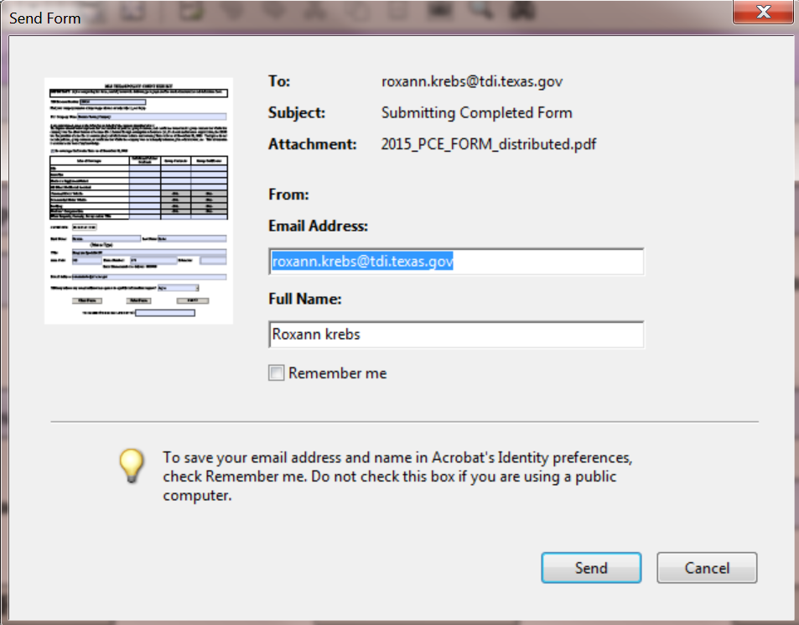

- You will receive an Adobe Acrobat prompt asking you if you would like to save the changes to the ‘2015 PCE FORM_distributed.pdf’ before closing. If you want to save the form, save it to a directory of your choice. If you do not want to save the form, click “No” and the form will close.
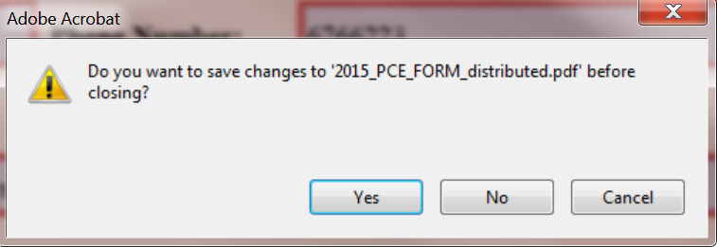

Thank you for your help with submitting the 2015 Policy Count Exhibit.

